. What is the role of the offset?
In partitions, messages are assigned a unique ID number called the offset. The role is to identify each message in the partition uniquely.

Distributed System - Definition
Also known as distributed computing and distributed databases, a distributed system is a collection of independent components located on different machines that share messages with each other in order to achieve common goals.
As such, the distributed system will appear as if it is one interface or computer to the end-user. The hope is that together, the system can maximize resources and information while preventing failures, as if one system fails, it won't affect the availability of the service.
Today, data is more distributed than ever, and modern applications no longer run in isolation. The vast majority of products and applications rely on distributed systems.
Elements of a Distributed System
The most important functions of distributed computing are:
- Resource sharing - whether it’s the hardware, software or data that can be shared
- Openness - how open is the software designed to be developed and shared with each other
- Concurrency - multiple machines can process the same function at the same time
- Scalability - how do the computing and processing capabilities multiply when extended to many machines
- Fault tolerance - how easy and quickly can failures in parts of the system be detected and recovered
- Transparency - how much access does one node have to locate and communicate with other nodes in the system.
Modern distributed systems have evolved to include autonomous processes that might run on the same physical machine, but interact by exchanging messages with each other.

Can we use Kafka without Zookeeper?
Yes, from version 2.8 and newer, we can use Kafka without a zookeeper. However, this version is not yet ready/available for production and lacks some key features.
In the older versions bypassing the zookeeper and connecting directly to the Broker was impossible. This was because it is impossible to fulfill the client's requests when the zookeeper is down.
Zookeeper
It helps in coordination between multiple services if multiple servers are running within the same cluster zookeeper helps in coordinating

A distributed system is a system where there is no single master, if one machine dies the other will take the charge.
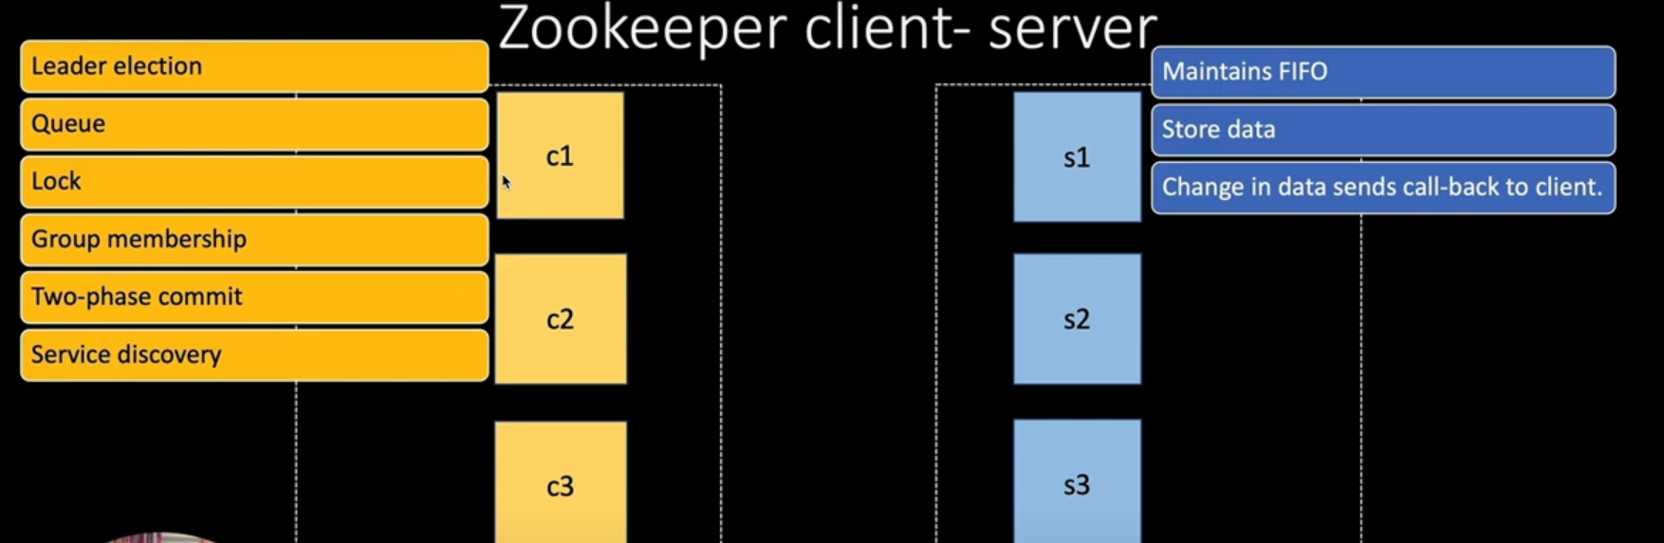
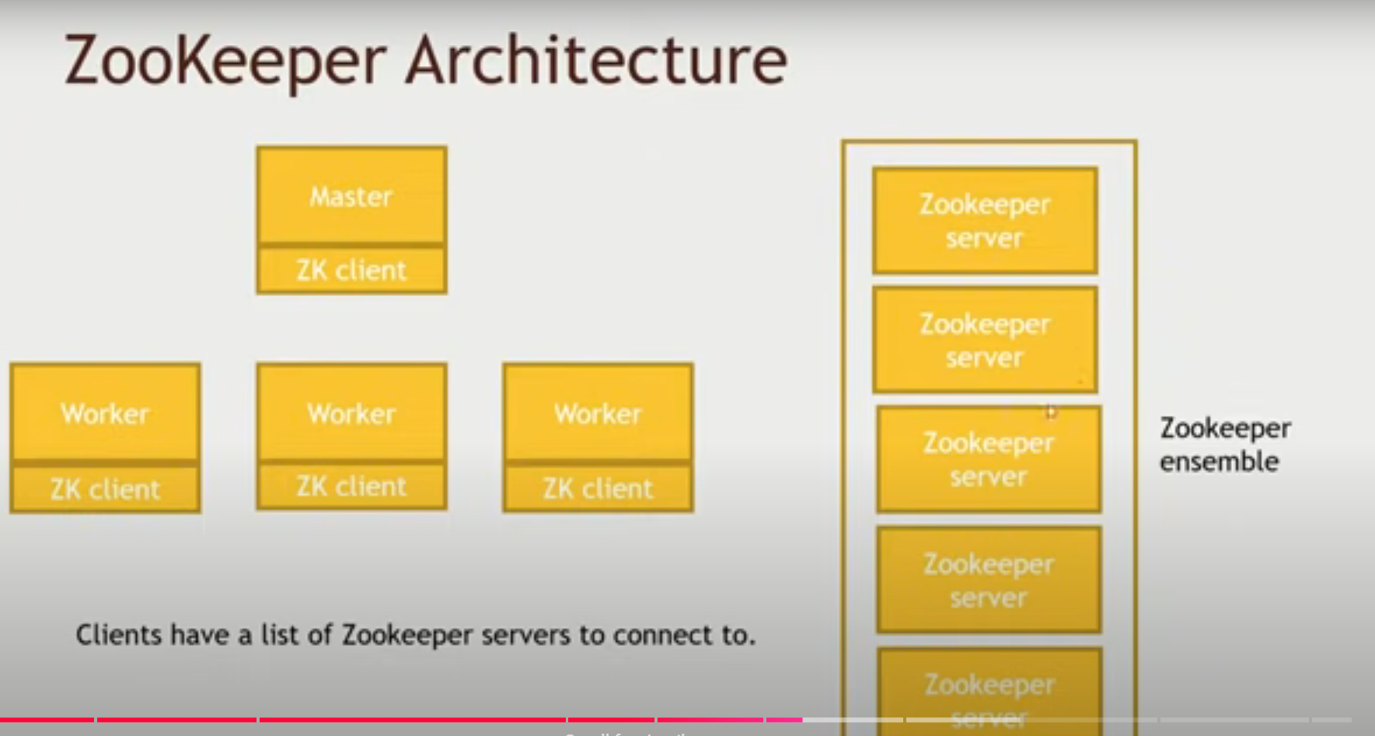

Zookeeper is a distributed, open-source coordination service for distributed applications. It exposes a simple set of primitives to implement higher-level services for synchronization, configuration maintenance, and group and naming.
In a distributed system, there are multiple nodes or machines that need to communicate with each other and coordinate their actions. ZooKeeper provides a way to ensure that these nodes are aware of each other and can coordinate their actions. It does this by maintaining a hierarchical tree of data nodes called “Znodes“, which can be used to store and retrieve data and maintain state information. ZooKeeper provides a set of primitives, such as locks, barriers, and queues, that can be used to coordinate the actions of nodes in a distributed system. It also provides features such as leader election, failover, and recovery, which can help ensure that the system is resilient to failures. ZooKeeper is widely used in distributed systems such as Hadoop, Kafka, and HBase, and it has become an essential component of many distributed applications.
Why do we need it?
- Coordination services: The integration/communication of services in a distributed environment.
- Coordination services are complex to get right. They are especially prone to errors such as race conditions and deadlock.
- Race condition-Two or more systems trying to perform some task.
- Deadlocks– Two or more operations are waiting for each other.
- To make the coordination between distributed environments easy, developers came up with an idea called zookeeper so that they don’t have to relieve distributed applications of the responsibility of implementing coordination services from scratch.
What is distributed system?
- Multiple computer systems working on a single problem.
- It is a network that consists of autonomous computers that are connected using distributed middleware.
- Key Features: Concurrent, resource sharing, independent, global, greater fault tolerance, and price/performance ratio is much better.
- Key Goals: Transparency, Reliability, Performance, Scalability.
- Challenges: Security, Fault, Coordination, and resource sharing.
Coordination Challenge
- Why is coordination in a distributed system the hard problem?
- Coordination or configuration management for a distributed application that has many systems.
- Master Node where the cluster data is stored.
- Worker nodes or slave nodes get the data from this master node.
- single point of failure.
- synchronization is not easy.
- Careful design and implementation are needed.
Apache Zookeeper
Apache Zookeeper is a distributed, open-source coordination service for distributed systems. It provides a central place for distributed applications to store data, communicate with one another, and coordinate activities. Zookeeper is used in distributed systems to coordinate distributed processes and services. It provides a simple, tree-structured data model, a simple API, and a distributed protocol to ensure data consistency and availability. Zookeeper is designed to be highly reliable and fault-tolerant, and it can handle high levels of read and write throughput.
Zookeeper is implemented in Java and is widely used in distributed systems, particularly in the Hadoop ecosystem. It is an Apache Software Foundation project and is released under the Apache License 2.0.
Architecture of Zookeeper
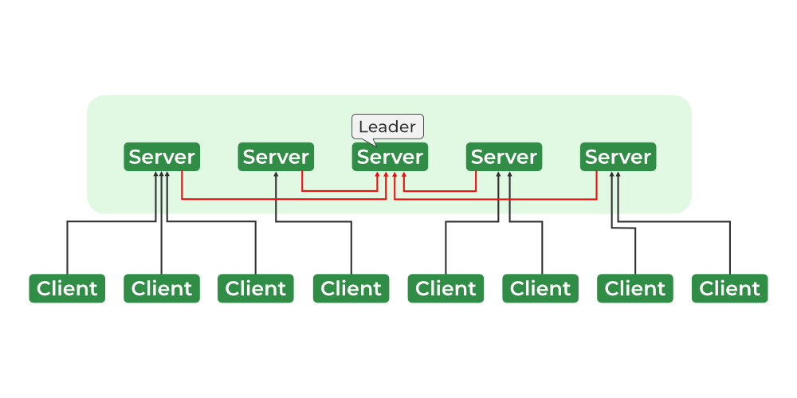
Zookeeper Services
The ZooKeeper architecture consists of a hierarchy of nodes called znodes, organized in a tree-like structure. Each znode can store data and has a set of permissions that control access to the znode. The znodes are organized in a hierarchical namespace, similar to a file system. At the root of the hierarchy is the root znode, and all other znodes are children of the root znode. The hierarchy is similar to a file system hierarchy, where each znode can have children and grandchildren, and so on.

- Leader & Follower
- Request Processor – Active in Leader Node and is responsible for processing write requests. After processing, it sends changes to the follower nodes
- Atomic Broadcast – Present in both Leader Node and Follower Nodes. It is responsible for sending the changes to other Nodes.
- In-memory Databases (Replicated Databases)-It is responsible for storing the data in the zookeeper. Every node contains its own databases. Data is also written to the file system providing recoverability in case of any problems with the cluster.
Other Components
- Client – One of the nodes in our distributed application cluster. Access information from the server. Every client sends a message to the server to let the server know that client is alive.
- Server– Provides all the services to the client. Gives acknowledgment to the client.
- Ensemble– Group of Zookeeper servers. The minimum number of nodes that are required to form an ensemble is 3.
Zookeeper Data Model
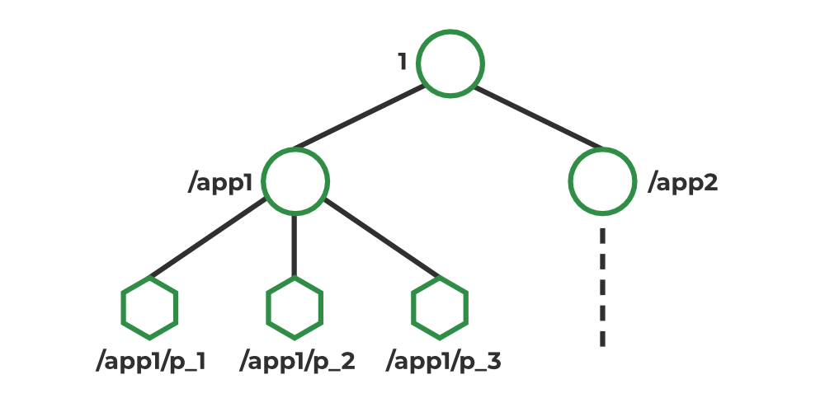
ZooKeeper data model
In Zookeeper, data is stored in a hierarchical namespace, similar to a file system. Each node in the namespace is called a Znode, and it can store data and have children. Znodes are similar to files and directories in a file system. Zookeeper provides a simple API for creating, reading, writing, and deleting Znodes. It also provides mechanisms for detecting changes to the data stored in Znodes, such as watches and triggers. Znodes maintain a stat structure that includes: Version number, ACL, Timestamp, Data Length

Why is Zookeeper necessary for Apache Kafka?
Controller election
The controller is one of the most important broking entities in a Kafka ecosystem, and it also has the responsibility to maintain the leader-follower relationship across all the partitions. If a node by some reason is shutting down, it’s the controller’s responsibility to tell all the replicas to act as partition leaders in order to fulfill the duties of the partition leaders on the node that is about to fail. So, whenever a node shuts down, a new controller can be elected and it can also be made sure that at any given time, there is only one controller and all the follower nodes have agreed on that.
Configuration Of Topics
The configuration regarding all the topics including the list of existing topics, the number of partitions for each topic, the location of all the replicas, list of configuration overrides for all topics and which node is the preferred leader, etc.
Access control lists
Access control lists or ACLs for all the topics are also maintained within Zookeeper.
Membership of the cluster
Zookeeper also maintains a list of all the brokers that are functioning at any given moment and are a part of the cluster.
Please note that you can’t run Kafka services without first installing Zookeeper. However, Zookeeper is already installed and configured for your CloudKarafka cluster.

ZooKeeper plays a vital role in the Apache Kafka project by providing a centralized system for managing cluster metadata and distributed coordination:

- Configuration management: ZooKeeper stores configuration information for the cluster, including topic creation, deletion, and partition changes. This ensures that all brokers in the cluster have a consistent view of the configuration.

- Leader election: ZooKeeper chooses a leader broker for each partition in the cluster. The leader broker handles all reads and writes, while followers replicate the leader's data.

- Access control lists: ZooKeeper stores Access Control Lists (ACLs) for all topics, which define permissions for reading and writing on each topic.

- Membership management: ZooKeeper detects and updates the cluster when a broker joins or leaves.

- Cluster topology: ZooKeeper manages the cluster topology, including tracking when topics are created or deleted, and when brokers enter or exit the cluster.

- In-sync view: ZooKeeper provides an in-sync view of the Kafka cluster.

ZooKeeper is a critical component of the Kafka cluster, ensuring that the system is organized and reliable. However, some say that ZooKeeper can become a bottleneck, limiting the number of partitions a single broker can handle. The Kafka community is working on removing ZooKeeper and using KRaft instead.

Apache Kafka makes use of Zookeeper to manage the following:
- In a Kafka ZooKeeper cluster, ZooKeeper tracks broker membership, topic configuration, leader selection, and metadata related to Kafka topics, brokers, and consumers.
- It stores the configuration of Kafka topics, stores the configuration of topics, and chooses leaders for each partition.

ZooKeeper is an essential Kafka component that is highly available and dependable, essential for Kafka to function properly.
Roles of ZooKeeper in Kafka
In a Kafka ZooKeeper cluster,Kafka and ZooKeeper collaborate to build a Kafka Cluster, with ZooKeeper providing distributed clustering and Kafka managing data streams and client communication.
a. In Kafka Brokers
Kafka brokers are essential components of Apache Kafka, responsible for partition management, message replication, fault tolerance, and collaborating with ZooKeeper for cluster coordination and metadata management.
The following are ZooKeeper's primary functions within Kafka brokers:
- Registration of Broker:
Kafka brokers register with ZooKeeper to enable other brokers and clients to find and contact them, and ZooKeeper keeps track of active brokers and their connection information.
- Membership of Cluster:
ZooKeeper keeps track of the Kafka cluster's active brokers and stores membership information, allowing for dynamic cluster membership changes and a current view.
- Controller Election:
ZooKeeper makes the controller election process easier by ensuring that only one broker is the controller at any given time.
- Cluster Events and Alerts:
ZooKeeper sends alerts to Kafka brokers about cluster events and changes. For example, if a broker fails or quits the cluster, ZooKeeper can alert the other brokers.
b. In Kafka Consumers
Kafka consumers use ZooKeeper to coordinate, monitor, record offsets, and perform partition rebalancing within a consumer group. ZooKeeper is used to read data from Kafka topics.
The following are ZooKeeper's primary functions within Kafka Consumers:
- Cluster Coordination:
ZooKeeper is responsible for arranging consumer groups in Kafka and keeping track of active groups and their members, as well as group membership information such as customers and partitions.
- Group Membership and Rebalancing:
ZooKeeper simplifies group membership management by assigning partitions fairly among active consumers and coordinating the partition reassignment process when group membership changes.
- Offset Commitment:
Kafka consumers store their current offset, which can be managed by ZooKeeper, which maintains committed offset information for each consumer group.
- Consumer Metadata:
ZooKeeper saves consumer-related metadata, which other components or monitoring systems can utilize to track the progress and status of individual consumers or consumer groups.
How Kafka and ZooKeeper Work Together?
ZooKeeper is used by Kafka to coordinate clusters, maintain metadata, track broker availability, facilitate leader election, and manage consumer groups, as well as handle dynamic configuration changes.
Controller Election
- To choose the Controller, each broker attempts to create an "ephemeral node" (a znode that will exist until the session that created it ends) called controller.
- The controller will be the first broker to create this ephemeral node, and future broker requests will receive the "node already exists" message.
- When a controller fails, brokers initiate a new round of controller elections to take over the failed controller's tasks.
Cluster Membership
- A group of brokers identified by a special numeric ID form a Kafka cluster.
- A group znode is generated when the brokers connect to the respective ZooKeeper instances, and each broker then constructs an ephemeral znode inside of this group znode.
Topic Configuration
- Each Kafka topic has its topic configuration, which may be applied at both the per-topic and global levels.
- Each topic's option has a default value that may be changed on a global or per-topic basis.
- The replication factor, limit message size, flush rate, unclean leader election, and message retention are all topic settings.
- The minimum number of replicants, maximum message size, flush rate, unclean leader election, and message retention are all determined by these settings.
Access Control Lists
- Apache Kafka includes an authorizer that supports access control lists (ACLs) via ZooKeeper.
- If an authorizer is defined in the Kafka server.properties file, access to resources is restricted to super users.
- When an authorizer is enabled, only super users have access to resources that do not have an associated ACL.
Quotas
- Quotas can be used by Kafka brokers to limit the number of broker resources that consumers can utilize.
- Client quotas are classified into two types: network bandwidth restrictions established by a byte-rate threshold and request rate constraints defined by a CPU utilization threshold.
- Quotas can be applied to user+client-id groups as well as user or client-id groups, with the most specific quota matching a particular connection being utilized.
- Overriding default quotas at any of the quota levels that must be smaller or larger than the default.
The Hardware of the ZooKeeper Server
- Memory:
ZooKeeper is not a memory-intensive application when dealing with simply Kafka-stored data. In a typical production use case, a minimum of 8 GB of RAM should be available for ZooKeeper.
- CPU:
ZooKeeper is a Kafka metadata store that does not require a lot of CPU resources and has a latency-sensitive feature, so it should be given a dedicated CPU core.
- Disk:
Disk performance is critical for maintaining a healthy ZooKeeper cluster. We advocate utilizing SSDs for best performance because ZooKeeper requires low-latency disk writes.
- Java Virtual Machine (JVM):
ZooKeeper is often used as a JVM but should have a 1 GB heap size and monitor heap utilization to avoid garbage collection delays.
How to Connect to Zookeeper?
ZooKeeper has several configuration settings that may be modified to enhance its functionality, dependability, and behavior.
Configuration Options for ZooKeeper
The following are some essential setup parameters for ZooKeeper:
- dataDir:
The data directory (dataDir) specifies the location of the directory in which transaction logs and snapshots are kept by ZooKeeper.
Example:
dataDir=/var/lib/zookeeper
- clientPort:
Determines the port number on which ZooKeeper looks for client connections (clientPort). This port is used by clients to connect to ZooKeeper.
Example:
clientPort=2181
- Tick Time (tickTime):
ZooKeeper's tick setting controls how long a tick lasts, which affects time-related parameters such as synchronization and session timeout.
Example:
tickTime=2000
- Init Limit (initLimit) and Sync Limit (syncLimit):
ZooKeeper settings determine the number of ticks required for initial sync and synchronization, affecting how long it takes for a ZooKeeper server to join or recover from a failure.
Example:
initLimit=10, syncLimit=5
- Maximum Client Connections (maxClientCnxns):
ZooKeeper server load is controlled by setting the maximum number of concurrent client connections per IP address, preventing excessive connections.
Example:
maxClientCnxns=100
Advantages of ZooKeeper
ZooKeeper has many advantages that make it a popular choice in distributed systems for distributed coordination and synchronization.

- Reliability:
ZooKeeper is a highly dependable service that is built to resist downtime.
- Simplicity:
With the use of a common hierarchical namespace, coordination is accomplished.
- Speed:
In circumstances when 'Reads' are more numerous, it operates with a 10:1 ratio, which is extremely fast.
- Scalability:
We can efficiently improve performance without any downtime by adding extra machines and making little changes to the application settings as necessary.
What is Zookeeper in Kafka and what does Zookeeper do?
How do the Kafka brokers and clients keep track of all the Kafka brokers if there is more than one? The Kafka team decided to use Zookeeper for this purpose.
Zookeeper is used for metadata management in the Kafka world. For example:
- Zookeeper keeps track of which brokers are part of the Kafka cluster
- Zookeeper is used by Kafka brokers to determine which broker is the leader of a given partition and topic and perform leader elections
- Zookeeper stores configurations for topics and permissions
- Zookeeper sends notifications to Kafka in case of changes (e.g. new topic, broker dies, broker comes up, delete topics, etc.…)

